Category
Comparative Void-Volume Analysis of Psychrophilic and Mesophilic Enzymes
Diana I Paredes^{1,*}, Kyle Watters¹, Derek Pitmad, Chris Bystroff² and Jonathan S. Dordick¹
¹Department of Chemical and Biological Engineering, Address etc.
²Department of Biology, Address etc.

abstract
Motivation:

- Introduction

During the last decade there has been increased interest in industry and academia to study and exploit microorganisms that grow under extreme conditions. This has resulted in a critical examination of their potential for use as intact microorganisms or as individual enzymes in the food, detergent, and pulp and paper industries [Sowers]. This is especially true in the food industry, where there has been a greater movement toward colder processing. Utilizing enzymes active at low temperatures could reduce spoilage from more common bacteria and avoid altering the taste of food through processes like Pasteurization[Kyle - Nakagawa]. Of specific interest are psychrophilic and thermophilic microorganisms, which are capable of thriving in low and high temperatures, respectively. Many studies have been conducted to elucidate the molecular basis of catalytic activity and enzyme stability in these organsims. Generally, thermophilic enzymes are catalytically active at higher temperatures, unlike psychrophilic proteins, which display optimum catalytic activity at low temperatures and are inactivated at moderate temperatures[]. Psychrophiles, of interest in this study, exist in a variety of low temperature environments. Microcracks in ice sheets contain liquid water, creating a niche for these extremophiles. In particular, it has been proposed by Price that psychrophiles living in Arctic ice travel through the ice via interconnected cracks[Kyle – Price]. These types of discoveries have far reaching implications for discovering life beyond our planet. It has been shown that common bacteria like E. coli can exist in these types of cracks at pressures in excess of 1200 MPa. At these pressures, ice-VI forms, a solid state of water that has not been observed on Earth, and has only been produced in a laboratory setting[Kyle – Sharma, Deming – microbial activity gigpascal pressures].
A common hypothesis has emerged that indicates psychrophilic enzymes possess higher protein flexibility compared to their homologous mesophilic and thermophilic proteins [Beeumen]. However, thermostable proteins from thermophilic organisms are more frequently analyzed than those found in psychrophiles. Further, the field comparing thermophiles to mesophiles is more exploited than the field studying differences between psychrophiles and mesophiles[]. However, some questions aimed to understand the differences between mesophilic and thermophilic proteins (amino acid type, hydrogen bonds, salt bridges, etc) have already been addressed to the differences between psychrophilic and mesophilic proteins. Our research has indicated that there is no one trait that can be generalized to all psychrophiles which set them apart from mesophiles. Psychrophiles can be separated into distinct “families” that have each evolved a unique adaptation that allow them to survive at low temperatures[]. Experiments suggest small molecular changes that vary within each protein family.
The results of thermophilic enzyme studies have helped to correlate molecular features with thermostability. These same trends may help understand psychrophilic molecular properties. For example, consider the compact hydrophobic packing found in the cores of thermophilic proteins; many researchers have demonstrated a strong correlation between high core packing and thermostability. Stronger hydrophobic packing in the core of a thermophilic protein increases the energy needed to unfold the protein, making it possible for thermophilic proteins to have an optimum activity at higher temperature. Experiments supporting this hypothesis have shown that protein thermostability diminishes when cavities are created in the protein[]. In the case of psychrophilic proteins, only a few studies have analyzed these cavities with a small set of proteins[]. The results indicate that there is no relationship between a weak hydrophobic core and cold-loving proteins, as might be expected from the opposite correlation in thermophiles. Recently, however, an increasing number of 3D structures of psychrophilic proteins have offered the opportunity to study them in more detail.
In this paper we present an analysis of a significant correlation between cavities in psychrophilic proteins and catalytic activity at low temperatures. The data was obtained using a set of 20 non-redundant psychrophilic proteins, each paired to a homologous mesophilic protein (sequence identity between 35-80%). In addition to the calculated void volumes, we obtained the following data: 1) amino acid frequency in residues neighboring cavities and 2) surface accessible solvent area of atoms surrounding cavities.

2. Methods
2.1 Database construction
The proteins used in this study were collected from the Protein Data Bank (PDB). The first set all consisted of PDB structures, proposed in Ref 10 \cite{Sowers} from cold adapted enzymes. To be considered in the first set, each protein was required to have chains at least 150 amino acids long and a resolution < 2.5 A. A second set of analogous mesophilic proteins was also obtained for comparison to the first (see Figure 1): First, using DaliLite software (to compare structures in 3D) we obtained a set of psychrophilic proteins valid for comparison to their mesophilic homologs, using a requirement of 30-85\% sequence identity. Second, we discarded proteins that have more than 2.5 A resolution, and used the PFAM database to determine whether or not they belong to the psychrophilic protein family. Third, by using the Prokaryotic Growth Temperature Database (PGTdb) we clustered all proteins by their growth temperature (psychrophiles 0-20,mesophiles 20-45 and thermophiles 45-100 °C). All eukaryotic organisms were assumed to be mesophiles, with few exceptions.

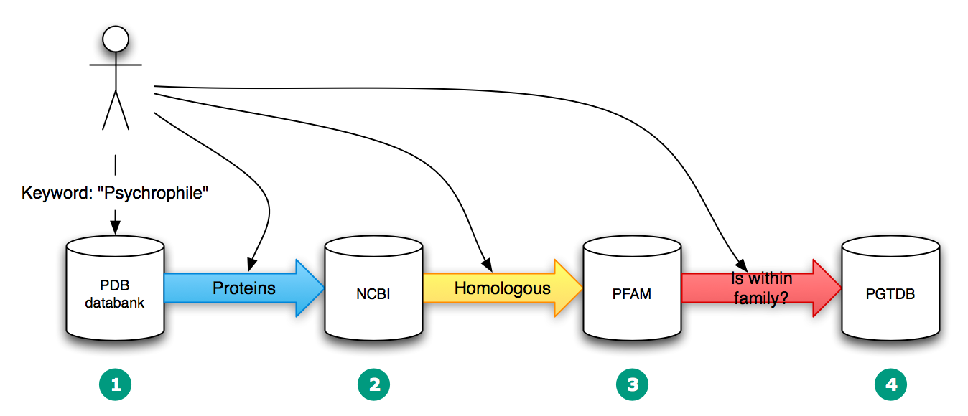
Figure 1. Flowchart methodology of pipeline algorithm used to build the psychrophilic with homologous protein dataset.
2.2 Void Volume
Cast program \cite{Dundas} uses Delaunay triangulation and the alpha complex to determine cavities and pockets. It outputs the amino acids involved in the cavity/pocket, the surface volume (using the solvent accessible surface and molecular surface), and the number of exits from the pocket (pocket mouth). A cavity is denoted by a pocket with zero exits. CASTp was used to identify cavities within the subunit of the protein. In order to do so, the software essentially “probes” the subunit for cavities with a sphere size set by the user. For this study, calculations were done at radii 0.6, 0.8, 1.0, 1.2, 1.3, 1.35,1.4 (water molecule size), 1.45, 1.5, 1.6 and 1.8 Å. The results from the CASTp calculations were then used to obtain the following data from each protein: 1) Total number of cavities normalized by molecular weight (Cav\#). 2) Total volume inside the cavities (using accessible surface) normalized by molecular weight (Vol\#). 3) Total cativity volume per cavity (Vol\#/Cav\#).

2.3 Statistical analysis
We ran a paired two sample t-test to determine if all the psychrophilic proteins (paired to a corresponding mesophilic homologous protein), have different mean void volumes, cavity volumes, etc. A p-value less than 0.01 was considered statistically significant.

3 Results
3.1 Database construction.
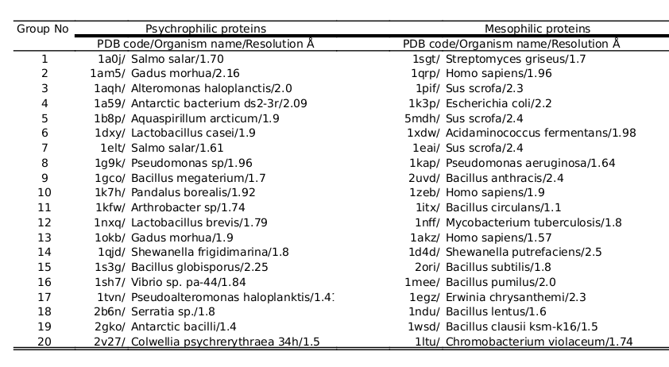
Applying the selection criteria described above yielded 20 pairs of psychrophile/mesophile homologs. The protein pairs come from a range of organisms and shown in Table 1
Table 1. List of enzymes used in the work

3.2 The average volume per cavity
To investigate the differences between void volume in psychrophiles and mesophiles, water-sized and smaller spheres were used to computationally probe the inside of protein molecules to identify protein cavities. Void volume in proteins can be divided in two main groups: pockets and cavities. Pockets are depths in the proteins with one or more exits, while cavities are void volumes inside the protein with no exits relative to the probe used. In this case, probe-sizes of 0.3, 0.6, 0.8, 1.0, 1.2, 1.4, 1.6 and 1.8 Å were used. The use of different probe sizes was to observe if protein packing in psychrophiles is different at a very small scale (0.6 Å) from the size of a water-molecule (1.4 Å) and beyond. The void volume was calculated using an algorithm from CASTp[]. CASTp has been compared to many other algorithms, and shows great reliability at finding cavities and pockets.

Figure 2. Boxes demonstrate the average size of cavities in psychrophilic proteins subtracted from the average sizes of the mesophilic cavities. Positive deviation from zero on the y-axis indicates higher average cavity size in psychrophilic proteins at the probe-sizes indicated on the x-axis. Red stars indicate statistically significant differences in average cavity size (p<0.05).
`

As given in Appendix A, the paired proteins were analyzed by total void volume (pockets and cavities), total pocket volume, total cavity volume, and the total number of voids, pockets and cavities. The data was not normalized by the molecular weight (MW) because each protein pair has similar MW.
Instead, the average total void volume, the average pocket volume, and the average cavity volume were calculated. In the latter, the paired t-test showed a significant difference in the psy-meso paired proteins (p<0.05) for average cavity-size volumes in the range of 1.4-1.5 Å (see Figure 2). On average, the difference in average cavity size between a psychrophilic and mesophilic protein is 3.5 Å³, which is comparable to the size of a water molecule: 3.6 Å³. The fact that the greatest differences in average cavity volume is at range 1.4-1.5 Å and vanish at 1.6 Å indicates an interesting morphology of the psychophilic cavities. This is observable in figure 3, the psychrophilic proteins in theory could hold much more water molecules at a probe size 1.5 Å than at 1.6 Å implying that cavities found at probe-size radii 1.4-1.5 Å are very amorphous and irregular; a cartoon representation of this hypothesis is shown in figure 4.
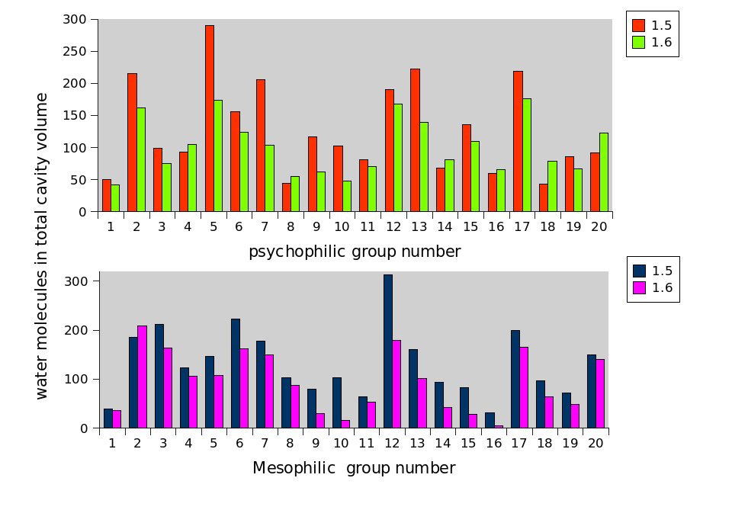
Figure 3. Theorical number of waters that could fit in the total void volume of cavities in the psychrophilic (top) and mesophilic (bottom) proteins at probe–size radii of 1.5 and 1.6 Å.

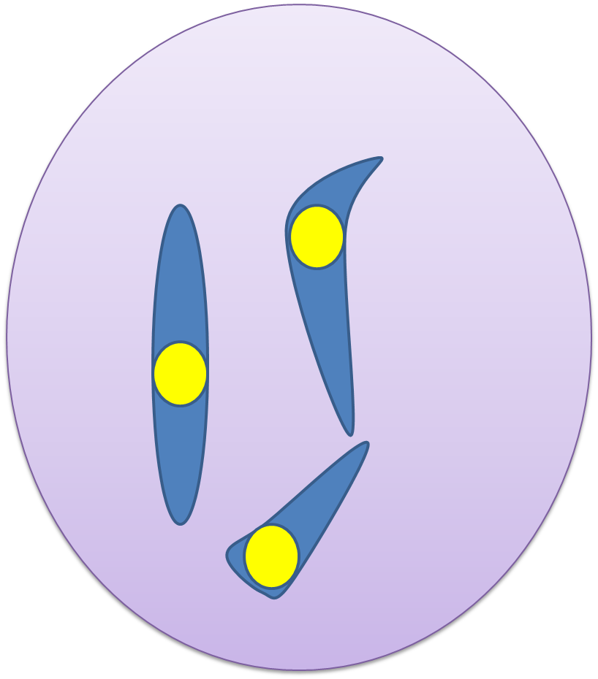

Figure 4. Cartoon representation of hypothesis in which amorphous cavities could in theory contain more than one water molecule (indicated by yellow circle) due to their high void volume. However, when a molecule bigger that 1.5 tries to be inserted in this cavity is not possible due to the cavity morphology.

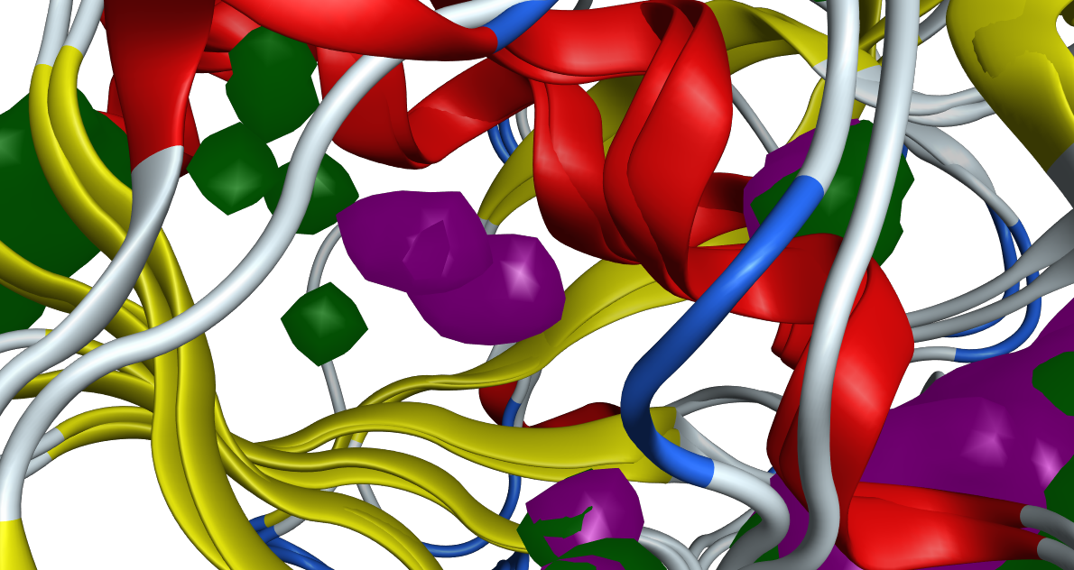
Figure 5. Superposition of psychrophilic and mesophilic hydrolases. Zoom in in cavities, green (mesophilic) purple (psychrophilic).

Figure 5 shows two superimpose hydrolase proteins with cavities found in psychrophilic (colored purple) and mesophilic (colores green) proteins; in here it is visible that psychrophilic cavities are bigger and more amorphous shaped compared to mesophilic cavities that are smaller and more spherical
The assumption that protein cavities are not empty comes from experiments with NMR, which prove that cavities may contain water molecules without being present in the X-ray structures[]. These studies go even further to prove that hydrophobic cavities can contain water as well. However, those water molecules have a very short resident time in the cavities[].

3.3 Amino acid frequency in psychrophilic cavities
To get a better understand cavity makeup, we characterized the types of amino acids that surround the cavities of the 20 paired psychrophilic and mesophilic proteins at probe-size radii 1.4 Å. Four groups of amino acids were considered: hydrophobic (), acidic (), basic() and uncharged(). Based on the observed frequencies of each (see Table 3), on average there more acidic amino acid residues forming the psychrophilic cavities than in homologous mesophilic protein (p<0.05). The cavities’ positions in psychrophilic proteins are more predominant in turns and coils, in contrast with mesophilic proteins (data not shown). These two characteristics in psychrophilic cavities have been described in studies where cavities contain structural water molecules[]. Park analyzed 6718 buried water molecules most of which formed hydrogen bonds with polar atoms, predominantly near residues that compose turn or coils. There are many studies on the effect of these water molecules in cavities; for example, Fisher et al. theoretically calculated the vibration entropy of protein bovine pancreatic trypsin inhibitor with bound and unbound W122 (a buried water molecule). The results indicate that bound water increases the vibrational entropy of the protein, which can also be thought of as an increase in flexibility[]. A similar result is obtained experimentally and computationally, where AUTHOR-NAME shows the stabilization of polar amino acid Glu-66 in staphylococcal nuclease by a water molecule. Water molecules in polar cavities make more stable hydrogen bonds and have a longer residence time than in hydrophobic cavities.

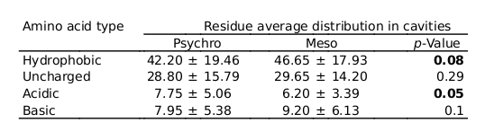

Table 3. Average type of residues surrounding the cavities.

Conclusion

A high percentage of Earth’s surface exists at low temperatures, which raises the question of how life in these environments has emerged. Before X-ray structures it was difficult to study the structural differences between cold-adapted enzymes and those that operate at higher temperatures. In this study, the internal packing of 20 psychrophiles were analyzed and statistically compared to 20 homologous mesophiles. This study reveals that: (1) the main differences in cavities occur at the water probe-size, (2) psychrophilic cavities contain a higher acidic amino acid content and (3) psychrophilic proteins have a bigger average cavity size compared to mesophilic proteins. The characteristics displayed by cavities indicates there is a high probability to be filled with water. The reason, however, why psychrophilic enzymes may evolve to be more internally hydrated is controversial; some studies show that cavity hydration increases structural stability, while others show more flexibility. Regardless, internal hydration has been shown to be related to lower thermal stability[]. The structure-based differences found in this study may reveal themselves to be critical characteristics related to cold adaptation and might help to design enzymes capable of work at low temperatures.
References

[1] Jie Liang and Ken A. Dill. Are proteins well-packed? Biophysical Journal,
81:751766, 2001.

[2] Ricardo Cavicchioli, Khawar S Siddiqui, David Andrews, and Kevin R Sowers.
Low-temperature extremophiles and their applications. Current Opinion in
Biotechnology, 13(6):253261, 2002.

[3] Filip Van Petegem, Tony Collins, Marie-Alice Meuwis, Charles Gerday, Georges
Feller, and Jozef Van Beeumen. The structure of a cold-adapted family 8 xylanase
at 1.3 resolution. THE JOURNAL OF BIOLOGICAL CHEMISTRY,
278(9):75317539, 2003.

[4] Radivojac P. and Obradovic Z. and Smith D. K. and Zhu G. and Vucetic S. and
Brown C. J. and Lawson J. D. and Dunker A. K. Protein flexibility and intrinsic
disorder. Protein Sci, 13(1):71–80, 2004.

[5] Papaleo E, Riccardi L, Fantucci P Villa C, and De Gioia L. Flexibility and
enzymatic cold-adaptation: a comparative molecular dynamics investigation of the
elastase family. Biochim Biophys Acta, 1764(8):1397–1406, 2006.

[6] Magne Olufsen, Arne O. Smals, Elin Moe, and Bjrn O. Brandsdal. Increased
flexibility as a strategy for cold adaptation a comparative molecular dynamics study
of cold- and warm-active uracil dna glycosylase*. J. Biol. Chem,
280(18):18042–18048, 2005.

[7] Spiwok V, Lipovov P, Sklov T, Duskov J, Hasek J Dohnlek J, Russell NJ, and
Krlov B. Cold-active enzymes studied by comparative molecular dynamics
simulation. J Mol Model., 13(4):485–97, 2007.

[8] Khawar Sohail Siddiqui and Ricardo Cavicchioli. Cold-adapted enzymes. Annu.
Rev. Biochem, 75:403–433, 2006.

[9] Rupert JM Russell, Ursula Gerike, Michael J Danson, David W Hough, and
Garry L Taylor. Structural adaptations of the cold-active citrate synthase from an
antarctic bacterium. Structure, 6(3):351–362, 1998.

[10] Marco Alvarez, Johan Ph. Zeelen, Veronique Mainfroid, Francoise Rentier-Delrue,
Joseph A. Martial, Lode Wyns, Rik K. Wierenga, and Dominique Maes.
Triose-phosphate isomerase (tim) of the psychrophilic bacterium vibrio marinus. J.
Biol. Chem, 273(4):2199 2206, 1998.

[11] Nushin Aghajari, Filip Van Petegem, Vincent Villeret, Jean-Pierre Chessa, Charles
Gerday, Richard Haser, and Jozef Van Beeumen. Crystal structures of a
psychrophilic metalloprotease reveal new insights into catalysis by cold-adapted
proteases. PROTEINS: Structure, Function, and Genetics., 50:636 647, 2002.

[12] Maaike de Backer, Sean McSweeney, Hanne B. Rasmussen, Bjrn W. Riise, Peter
Lindley, and Edward Hough. The 1.9 a crystal structure of heat-labile shrimp
alkaline phosphatase. J. Mol. Biol., 318:12651274, 2002.

[13] Thierry Lonhienne, Jerome Zoidakis, Constantinos E. Vorgias, Georges Feller,
Charles Gerday, and Vassilis Bouriotis. Modular structure, local flexibility and
cold-activity of a novel chitobiase from a psychrophilic antarctic bacterium. J. Mol.
Biol, 310:291–297, 2001.

[14] Marcelino A. M. and Gierasch L. M. Roles of b-turns in protein folding: From
peptide models to protein engineering. BIOPOLYMERS, 89(5):380–391, 2008.

[15] Sebastien Violot, Nushin Aghajari1, Mirjam Czjzek, Georges Feller, Guillaume K.
Sonan, Patrice Gouet, Charles Gerday, Richard Haser, and Veronique
Receveur-Brechot. Structure of a full length psychrophilic cellulase from
pseudoalteromonas haloplanktis revealed by x-ray diffraction and small angle x-ray
scattering. J. Mol. Biol, 348:12111224, 2006.

[16] Sarah Boswell, John Mathew, Michael Beach, Robert Osuna, and Wilfredo Colon.
Variable contributions of tyrosine residues to the structural and spectroscopic
properties of the factor for inversion stimulation. Biochemistry, 43:2964–2977,
2004.

[17] Ellen Kristin Riise, Marit SjoLorentzen, Ronny Helland, Arne O. Smalas,
a Hanna-Kirsti S.Leirosa, and Nils Peder Willassena. The first structure of a
cold-active catalase from vibrio salmonicida at 1.96 a reveals structural
crystallography aspects of cold adaptation. Acta Cryst, D63:135148, 2007.

[18] A. E. Eriksson, W. A. Baase, X.-J. Zhang, D. W. Heinz, M. Blaber, E. P. Baldwin,
and B. W. Matthews. Response of a protein structure to cavity-creating mutations
and its relation to the hydrophobic effect. Science, 255(5041):178–183, 1992.

[19] Joe Dundas, Zheng Ouyang, Jeffery Tseng, Andrew Binkowski, Yaron Turpaz, and
Jie Liang. Castp: computed atlas of surface topography of proteins with structural
and topographical mapping of functionally annotated resiudes. Nucleic Acid
Research, 34:W116–W118, 2006.

[20] Neelima Arora, Amit Kumar Banerjee, Srilaxmi Mutyala, and
Upadhyayula Suryanarayana Murty. Comparative characterization of commercially
important xylanase enzymes. 2009.

[21] Sarah Sainsbury, Laura A. Lane, Jingshan Ren, Robert J. Gilbert, Nigel J.
Saunders, Carol V. Robinson, David I. Stuart, and Raymond J. Owens. The
structure of crga from neisseria meningitidis reveals a new octameric assembly
state for lysr transcriptional regulators. 2009.

[22] Antonin Pavelka, Eva Chovancova, and Jiri Damborsky. Hotspot wizard: a web
server for identification of hot spots in protein engineering. 2009.

[23] Yan Yuan Tseng, Craig Dupree, Z. Jeffrey Chen, and Wen-Hsiung Li. Splitpocket:
identification of protein functional surfaces and characterization of their spatial
patterns. 2009.

[24] Olga V Kalinina, Mikhail S Gelfand, and Robert B Russell. Combining specificity
determining and conserved residues improves functional site prediction. 2009.

[25] Vincent Le Guilloux, Peter Schmidtke, and Pierre Tuffery. Fpocket: An open
source platform for ligand pocket detection. 2009.

[26] Xiao Jie Yao, Gisselle Vlez Ruiz, Matthew R. Whorton, Sren G. F. Rasmussen,
Brian T. DeVree, Xavier Deupi, Roger K. Sunahara, and Brian Kobilka. The effect
of ligand efficacy on the formation and stability of a gpcr-g protein complex. 2009.

[27] Li Xie, Jerry Li, Lei Xie, and Philip E. Bourne. Drug discovery using chemical
systems biology: Identification of the protein-ligand binding network to explain the
side effects of cetp inhibitors. 2009.

[28] Ayana Tomita, Tokushi Sato, Kouhei Ichiyanagi, Shunsuke Nozawa, Hirohiko
Ichikawa, Matthieu Chollet, Fumihiro Kawai, Sam-Yong Park, Takayuki Tsuduki,
Takahisa Yamato, Shin ya Koshihara, and Shin ichi Adachi. Visualizing breathing
motion of internal cavities in concert with ligand migration in myoglobin. 2009.

[29] Shilpa Deshpande Kaistha and Ranjana Sinha. Homology modeling of phosphoryl
thymidine kinase of enterohemorrhagic escherichia coli oh: 157. 2009.

[30] Alisa Wilantho, Sissades Tongsima, and Ekachai Jenwitheesuk. Pre-docking filter
for protein and ligand 3d structures. 2008.

[31] Dirk M. Zajonc, Harald Striegl, Christopher C. Dascher, and Ian A. Wilson. The
crystal structure of avian cd1 reveals a smaller, more primordial antigen-binding
pocket compared to mammalian cd1. 2008.

[32] T Andrew Binkowski and Andrzej Joachimiak. Protein functional surfaces: Global
shape matching and local spatial alignments of ligand binding sites. 2008.

[33] Ting-Ying Chien, Darby Tien-Hao Chang, Chien-Yu Chen, Yi-Zhong Weng, and
Chen-Ming Hsu. E1ds: catalytic site prediction based on 1d signatures of
concurrent conservation. 2008.

[34] Lin Wang, Alejandra Gamez, Holly Archer, Enrique E. Abola, Christineh N.
Sarkissian, Paul Fitzpatrick, Dan Wendt, Yanhong Zhang, Michael Vellard, Joshua
Bliesath, Sean Bell, Jeff Lemont, Charles R. Scriver, and Raymond C. Stevens.
Structural and biochemical characterization of the therapeutic a. variabilis
phenylalanine ammonia lyase.

[35] Abigail Go, Seho Kim, Jean Baum, and Michael H. Hecht. Structure and dynamics
of de novo proteins from a designed superfamily of 4-helix bundles. 2008.

[36] Dengming Ming, Judith D Cohn, and Michael E Wall. Fast dynamics perturbation
analysis for prediction of protein functional sites. 2008.

37] Ulrike Grosskinsky, Monika Schtz, Michaela Fritz, Yvonne Schmid, Marina C.
Lamparter, Pawel Szczesny, Andrei N. Lupas, Ingo B. Autenrieth, and Dirk Linke.
A conserved glycine residue of trimeric autotransporter domains plays a key role in
yersinia adhesin a autotransport. 2007.

[38] Arwen R. Pearson, Bradley O. Elmore, Cheng Yang, Joseph D. Ferrara, Alan B.
Hooper, and Carrie M. Wilmot. The crystal structure of cytochrome p460 of
nitrosomonas europaea reveals a novel cytochrome fold and heme-protein
cross-link.

[39] Rukman S. De Silva, Gabriela Kovacikova, Wei Lin, Ronald K. Taylor, Karen
Skorupski, and F. Jon Kull. Crystal structure of the vibrio cholerae quorum-sensing
regulatory protein hapr. 2007.

[40] Lei Xie and Philip E Bourne. A robust and efficient algorithm for the shape
description of protein structures and its application in predicting ligand binding
sites. 2007.

[41] Michael P. Cusack, Boris Thibert, Dale E. Bredesen, and Gabriel del Rio. Efficient
identification of critical residues based only on protein structure by network
analysis. 2007.

[42] S. Chakravarty, A. Bhinge, and R Varadarajan. A procedure for detection and
quantitation of cavity volumes in proteins. application to measure the strength of
the hydrophobic driving force in protein folding. journal of biological chemistry, 277(35):31345–31353, 2002.

[43] Gibrat JF, Madej T, and Bryant SH. Surprising similarities in structure comparison.
Curr Opin Struct Bio, 6(3):377–385, 1996.

[44] S. L. Huang, L. C. Wu, H. K. Laing, K.T. Pan, and J. T. Horng. Pgtdb: a database
providing growth temperatures of prokaryotes. Bionformatics, 20(2):276–278,
2004.

[45] G. Gianese, F. Bossa, and S. Pascarella. Comparative structural analysis of
psychrophilic and meso- and thermophilic enzymes. Proteins, 47(2):236–249, May
2002.

[46] Brian W. Matthews and Lijun Liu. A review about nothing: Are apolar cavities in
proteins really empty? Protein Science, 18(3):494–502, 2009.

[47] Jacob V. Maizel Chung-Jung Tsai and Ruth Nussinov. The hydrophobic effect: A
new insight from cold denaturation and a two-state water structure. Protein
Science, 37(2):55–69, 2002.

[48] Laurence D. Barron, Lutz Hecht, and Gary Wilson. The Lubricant of Life: A Proposal That Solvent Water Promotes Extremely Fast
Conformational Fluctuations in Mobile Heteropolypeptide Structure. Biochemestry. 36(43)
:13143-49, 1997.

[49] Ana Damjanovic, Bertrand Garcıa-Moreno,Eaton E. Lattman, and Angel E. Garcıa.
Molecular Dynamics Study of Water Penetration in
Staphylococcal Nuclease
. Proteins. 60:433– 449 .2005.

[50] Stefan Fischer, Chandra S. Verma, and Roderick E. Hubbard. Rotation of Structural Water inside a Protein: Calculation of the Rate and Vibrational
Entropy of Activation
. J. Phys. Chem. B 1, 102,1797-1805, 1998

[51] Takashi Imai, Ryusuke Hiraoka,Andriy Kovalenko,and Fumio Hirata. Water Molecules in a Protein Cavity Detected by a Statistical-Mechanical
Theory
. j. am. chem. soc.,127, 15334-15335
. 2005.

[52] Subramanian Vaitheeswaran, Hao Yin, Jayendran C. Rasaiah, and Gerhard Hummer. Water clusters in nonpolar cavities. PNAS ͉.101 (49) : 17002–17005 ͉ 2004 ͉

[53] Jeremy C. Smith, Franci Merzel, Ana-Nicoleta Bondar, Alexander Tournier and Stefan Fischer. Structure, dynamics and reactions of protein hydration water. Trans. R. Soc. Lond. B.359: 1181–1190
.2004 .

[54] Sheldon Park and Jeffery G. Saven. Statistical and Molecular Dynamics Studies of Buried
Waters in Globular Proteins
. Proteins. 60:450 – 463. 2005 .

[55] Szilvia Szep, Sheldon Park, Eric T. Boder, Gregory D. Van Duyne,1 and Jeffery G. Saven. Structural coupling between FKBP12
and buried water
. Proteins. 74:603–611.
2009.

́ ́ ́

* To whom correspondence should be addressed.

